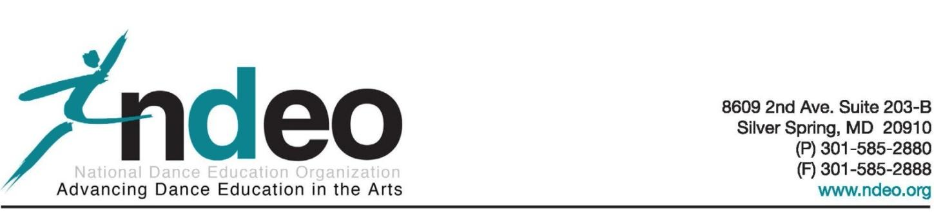
The National Honor Society for Dance Arts (NHSDA) is a program of the National Dance Education Organization (NDEO)

National Honor Society for Dance Arts Pledge

I pledge to never compromise my creative ability,
to be original and true to my body’s natural movement.
I will always be willing to improve my technique and stay open to new genres and ideas.
I will never fail to help fellow dancers to let their talents shine and to be an advocate for prospective dancers everywhere.
I will bring my personality and spirit to every dance that I am called to perform.
I recognize my induction as a privilege and I will do whatever I can to honor it. I will use my experiences in dance to connect the field and build knowledge. I will take responsibility and continue to develop leadership skills that will enhance experiences for myself and my peers. I will promote inclusiveness and unity through dance.

- Deloris Gayle Griffin

*Please note: The NHSDA pledge was written in Spring 2006 by Deloris Gayle Griffin, Senior at Ridge View High School in Columbia, South Carolina, and President, NHSDA Chapter SC 002.
The last paragraph was written by Gabrielle Stoler (MDEA Student Representative) to include MDEA priorities. Revised 7/7/2017.

